Dis-Indo-South Sulawesi, Toraja Grave Guardian

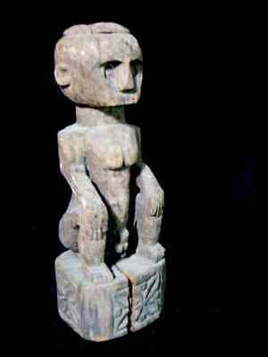 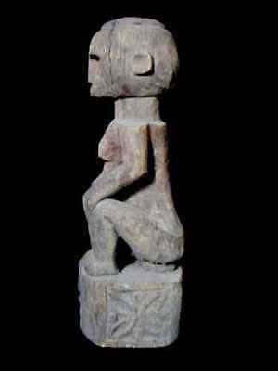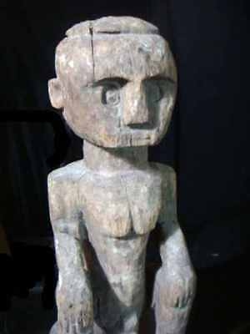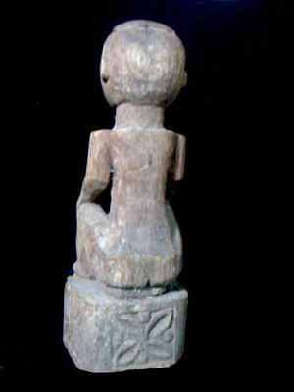

Toraja Grave Guardian from South Sulawesi, Indonesia

Formal Label: Toraja Grave Guardian from South Sulawesi, Indonesia

Accession Number: DS632.T7.A1

Date or Time Horizon: early 20th century

Geographical Area: South Sulawesi

Cultural Affiliation: Toraja

Media: wood; patina of figure is brownish-gray

Dimensions: H 30 in/72 cm

Weight:

Condition:

Provenance: from a grave priest

**Discussion:**

**References:**